Assignment 3.3 Contemporary Art comparison

Artwork 1: Campbell’s soup Cans – Andy Warhol (contemporary)
Artwork 2: Venus of Willendorf – prehistoric
Video: first YOUTUBE video provided

QUESTION | ARTWORK 1:  (contemporary) | ARTWORK 2 (older period) | VIDEO
1: Subject Matter | Mass-produced soup cans representing consumer culture and everyday products | A female figure representing fertility, motherhood, and survival | Modern product-focused content showing objects being presented or used
2: Medium | Silkscreen printing on canvas | Carved limestone sculpture | Digital video (YouTube/social media format)
3: Elements and principles of Design | Repetition, bold colors, balance, and uniformity that create a sense of mass production | Rounded shapes, emphasis on body form, texture, and proportion highlighting fertility | Bright colors, movement, close-up shots, contrast, and repetition to grab attention
4: Year and Place | 1962, United States | 25,000 BCE, Austria | 21st century, online/social media platform (global)
5: Social, Political, or spiritual ideas | Reflects consumerism, mass production, and popular culture in modern society | Represents fertility, survival, and spiritual beliefs about life and reproduction | Shows consumer culture, influence of media, and how products shape identity and lifestyle
6: Moral values represented | Highlights materialism and the value placed on everyday consumer goods | Emphasizes importance of fertility, life, and survival | Promotes modern values like success, lifestyle, and desire for material goods
7: Image | 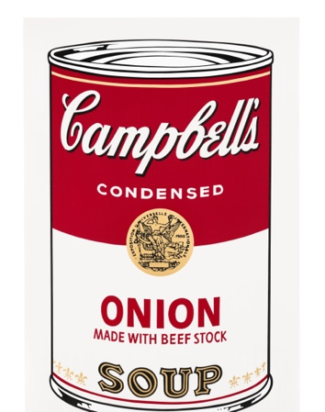 | 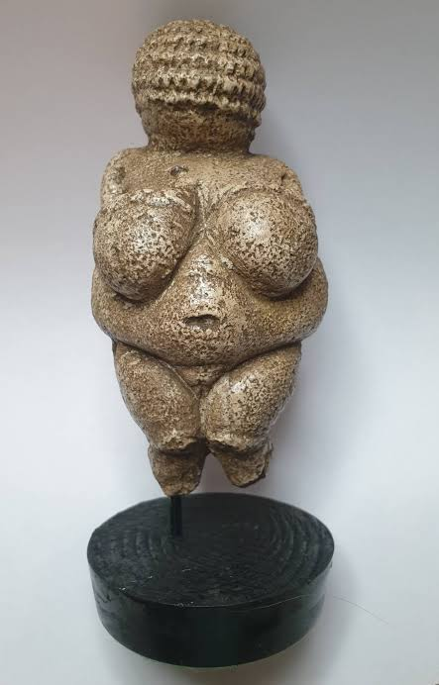 | N/A

Questions | Differences (What has changed) | Similarities (What has stayed the same)
What has changed? | Art has changed from representing survival and spiritual beliefs to focusing more on consumer culture, media, and modern lifestyles. Materials and techniques have also evolved from hand-carved objects to digital and mass-produced formats. | Art is still used to communicate ideas, values, and beliefs of society, even though the form has changed.
What has stayed the same? | Modern art focuses more on media, technology, and individual expression, while older art focused more on survival and spiritual beliefs. | Artists in all time periods use visual elements to express meaning, influence viewers, and reflect their culture.

